Physical Inventory

**Physical Inventory Menu**

This feature is designed to reconcile the DMIS inventory balance with the actual quantity in the warehouse or any other location in the dealership. A variance report is generated at the end of the process.

* **How to process the Physical Count in the system**

*Step 1: Open Physical Inventory Menu*

- Click on Tables & Files

-New Physical Inventory Menu

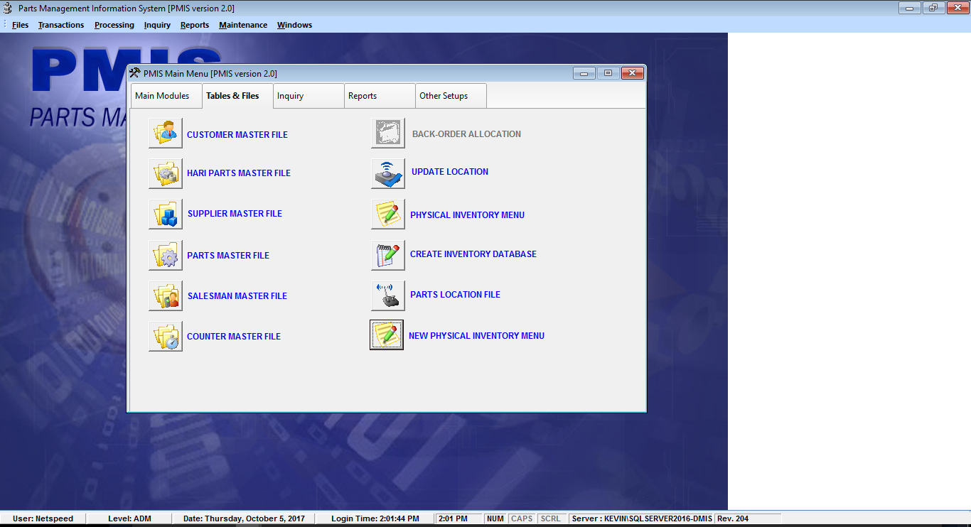

* *After selecting the* New Physical Inventory Menu*, this window will appear.*

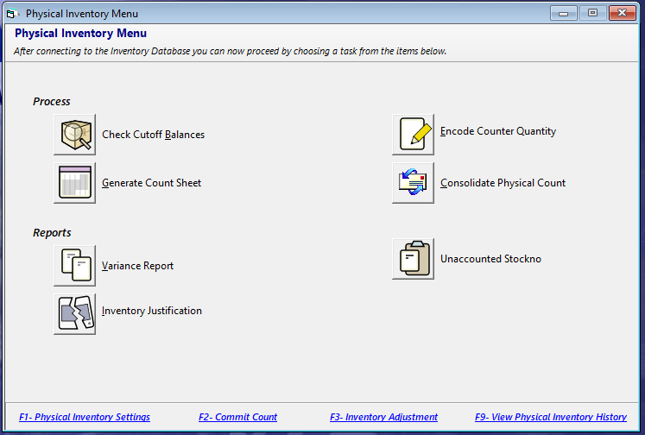

*Step 2: Create Physical Count Count Sheet*

1. Click Generate Count Sheet
2. Select Module Type.
3. Select Physical Count Date.
4. Click Process button to transfer all active stock Number from Master file to Count Sheet.
5. Click Print button to generate count sheet.

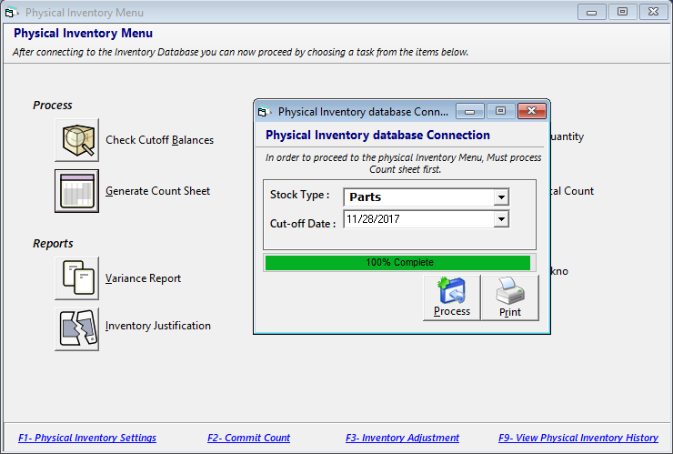

B

A

C

E

D

* *After clicking print button, Count Sheet will appear.*
* *Note: Tag no is automatically created upon transferring process of stock number.*

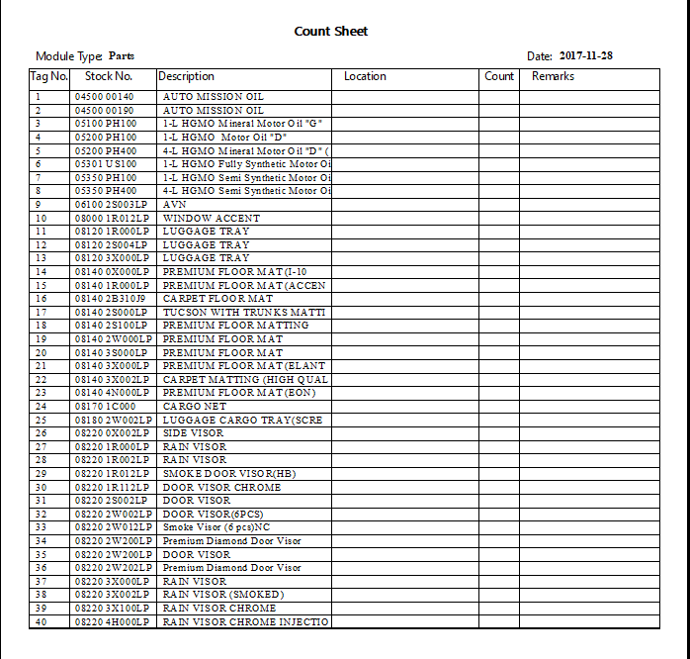

*Step 3: Physical count encoding*

1. Click Encode Counter quantity
2. Select Stock Type.
3. Encode Count. Location. Remarks then press enter to save data.
4. Page navigation.
5. Page Search.
6. Stock number Search.
7. Percentage completed.
8. Clicks add to manually encode Stock.
9. Print Count sheet

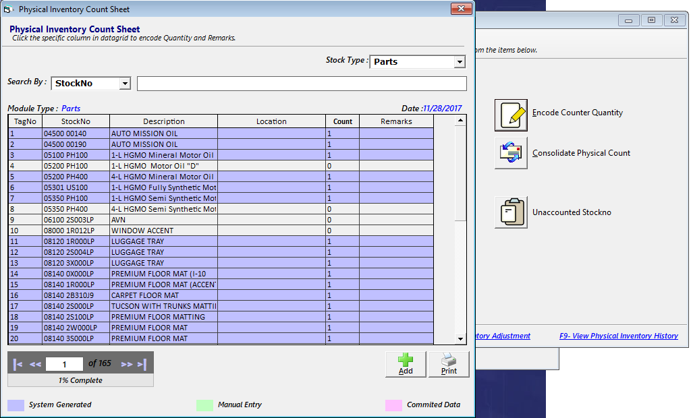

G

E

F

C

B

A

**I**

D

H

*Step 3.1: Physical count manual encoding of stock number*

1. *Search stock no.*
2. *Encode quantity location and remarks.*
3. *Clicks save.*

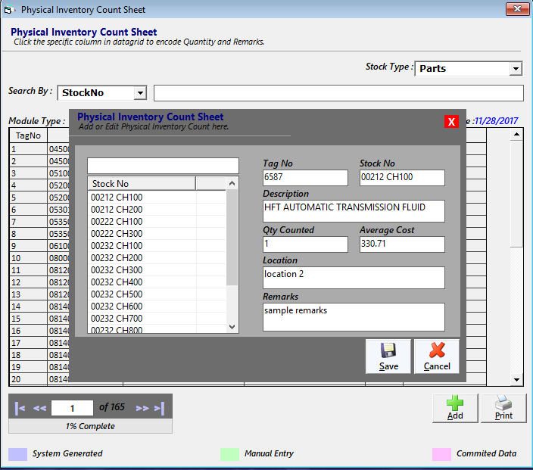

B

A

**C**

* Note: User can only edit the manually added stock.

*Step 4: Physical C manual encoding of stock number*

* *In order to have a variance report of the actual inventory, you need to process the Consolidate physical count first.*

1. *Click consolidate physical count*
2. *Select stock type*
3. *Select as of*
4. *Click consolidate*

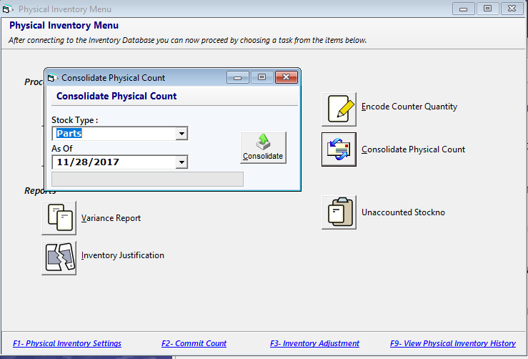

**D**

C

B

**A**

*Step 4: Variance Report*

* *Inventory Variance report shows the balancing of the actual inventory and the negative and positive variance of the physical count.*

1. *Click Variance Report*
2. *Select stock type*
3. *Select as of*
4. *Select Report Type*
5. *Click Print*

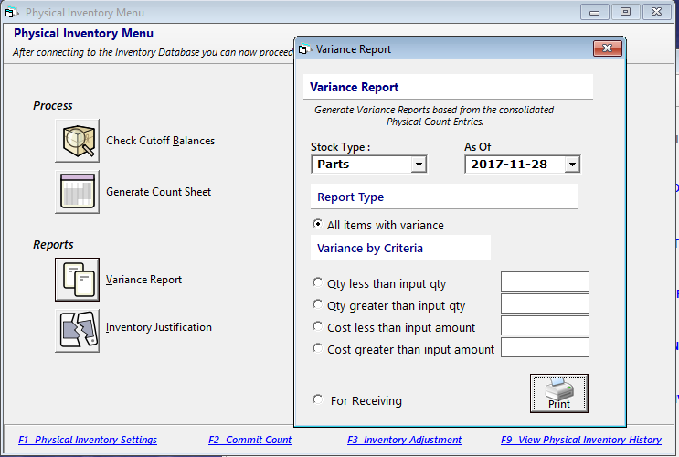

E

D

C

B

**A**

Variance report

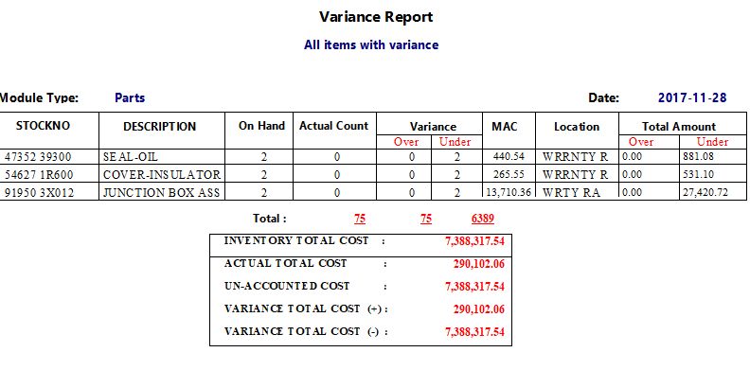

*Step 4.1: Justification Report*

1. *Click Justification Report*
2. *Select stock type*
3. *Select as of*
4. *Click Print*

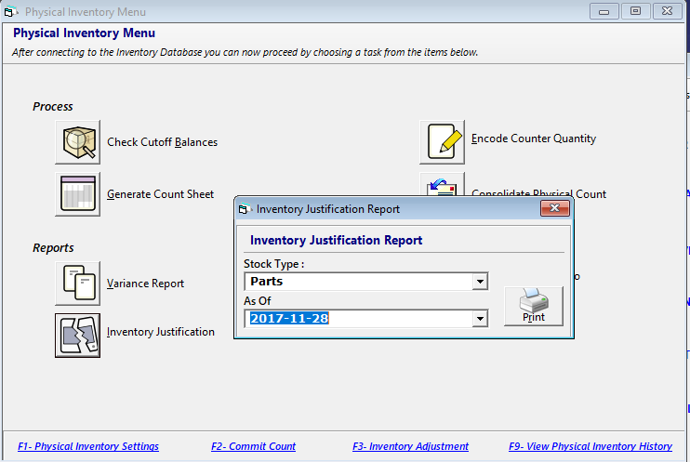

**D**

B

**A**

C

Justification Report

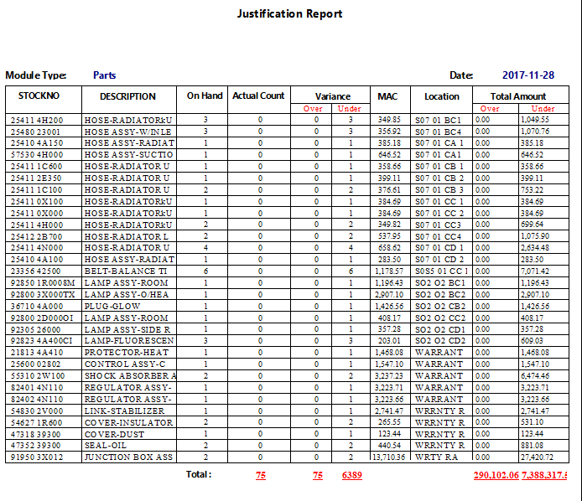

*Step 4.2: Unaccounted Report*

1. *Click Justification Report*
2. *Select stock type*
3. *Select as of*
4. *Click Print*

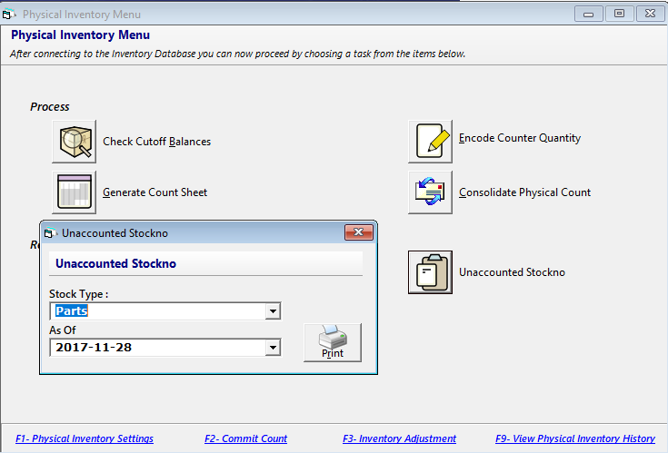

C

B

**D**

**A**

Unaccounted report

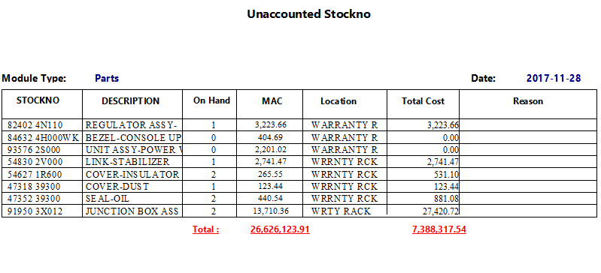

*Step 5: Commit Count*

1. *Press F2*
2. *Select stock type*
3. *Click Commit*

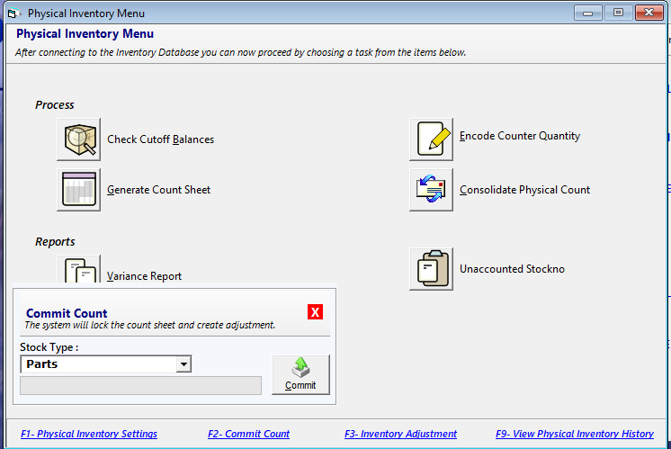

**C**

B

Step 6.1: Inventory adjustment

1. press F3
2. select stock type
3. Check all
4. Post Adjustment

Batch Posting

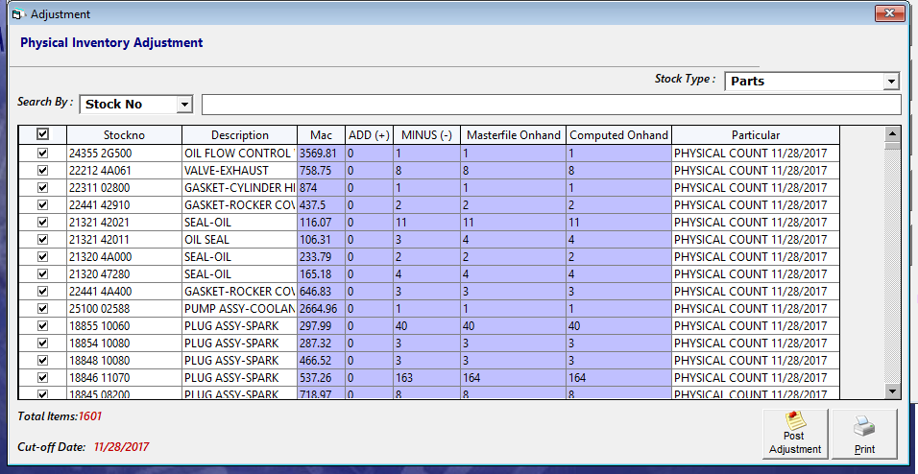

D

C

B

Or Post selected stock no

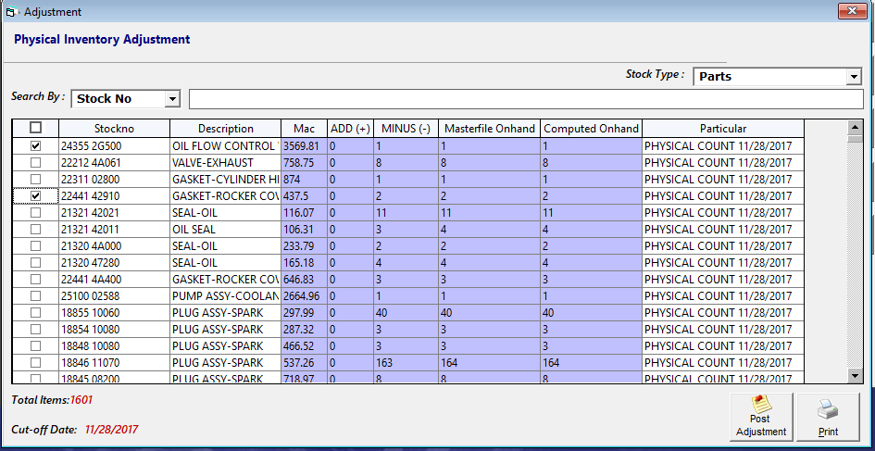

* Note: Posting of adjustment has two options it’s either batch posting or post selected data. To perform batch posting simply check the header check box then post.
* After posting adjustment this window will appear

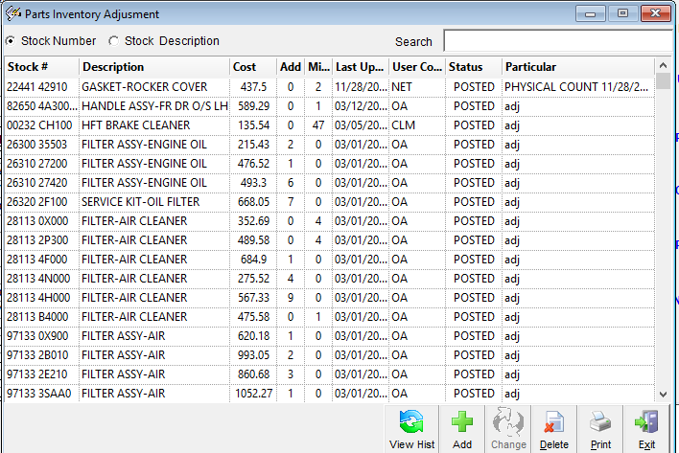

Physical count settings

1. Click Clear uncommitted Data then select stock type then click Clear button.
2. To Exclude all zero(0) on hand

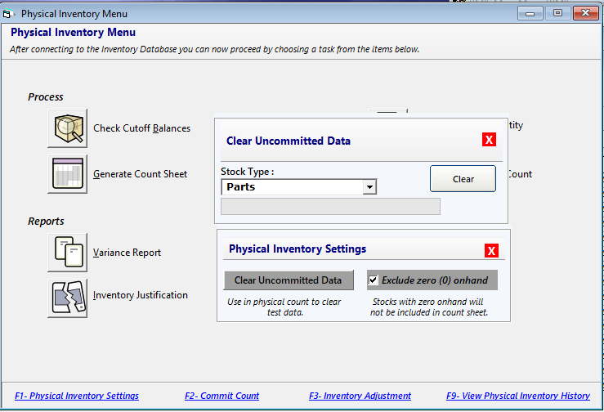

A

B

>>>>>>>>>> End of Physical Count <<<<<<<<<<